SPICA-VIS
SPICA_VIS/CHARA Co-Alignment Procedure

Authors: Stéphane Lagarde, Julien Dejonghe and Denis Mourard

Doc. No. : SPICA-VIS-0005

Issue : 21

Date : 08/07/2020

CHANGE RECORD
ISSUE | DATE | SECTION | COMMENTS
1 | 01/07/2020 | All | Creation
2 | 08/07/2020 | All | Ready for review

Table of Contents
1. Scope and Introduction 4
2. Check and adjustment modules 4
2.1 The control system 4
2.2 The adjustment devices 5
3. Procedures 6
2.1 Co-alignment procedure 7
2.2 Cophasing procedure 9

Scope and Introduction

The document describes the co-alignment and co-phasing procedures between CHARA and SPICA_VIS.
The location of the “SPICA_VIS feeding optics” mirrors (SFO-FOP) that feed the SPICA_VIS instrument does not allow the direct use of the CHARA reference source (see figure 1).
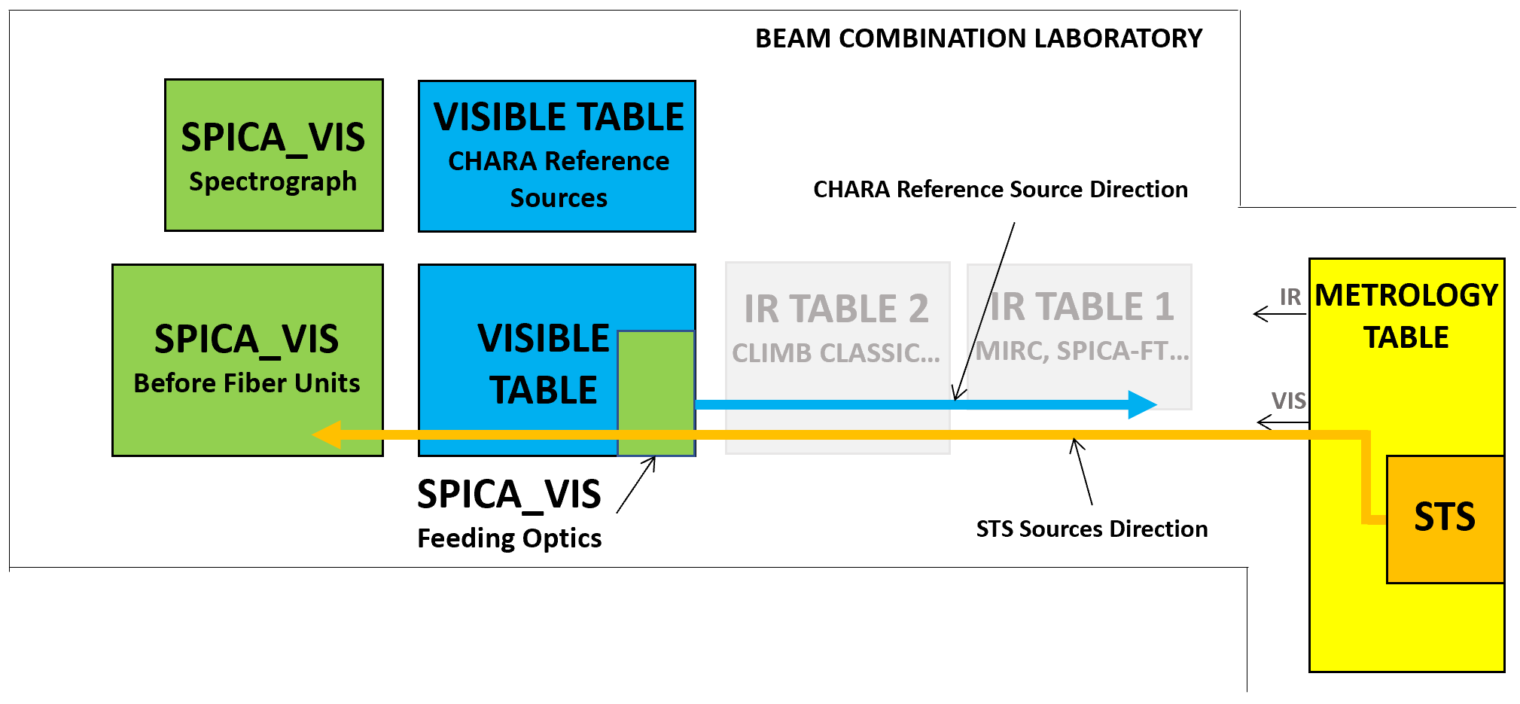
Figure 1: Schematic layout of the CHARA beam combination laboratory with the CHARA reference sources and the STS source.
The STS (Six Telescopes System) is necessary to perform the co-alignment and the co-phasing between CHARA and SPICA_VIS. The prerequisite of all the procedures described in this document is a preliminary co-alignment and the co-phasing between the CHARA reference sources and the STS sources. The alignment of the STS with CHARA will not be discussed in this document.

Check and adjustment modules

The goal of the co-alignment is to align the axis of the beam coming from the CHARA system (CHARA axis) to the SPICA_VIS axis.

2.1 The control system
To check the CHARA axis, a module called BCS (Beam Control System) has been added to the SPICA_VIS scientific instrument. This module is composed of (see figure 2):
- 6 individual mirrors FOM (Folding Mirrors) allowing to orient each beam on its specific location on the Beam Control Detector (BCD) i.e. the six beams (in pupil or image plan) can be observed simultaneously on the detector).
- A mirror BCC (Beam Control Camera) forms the 6 images on the detector BCD (Beam Control Detector).
- A motorized lens PIS (Pupil/Image Selector) can be inserted to image the pupil plan instead if the image one
A part of the beam coming from CHARA (20%) is sent to the BCS thanks to permanent beam splitters (BSP).
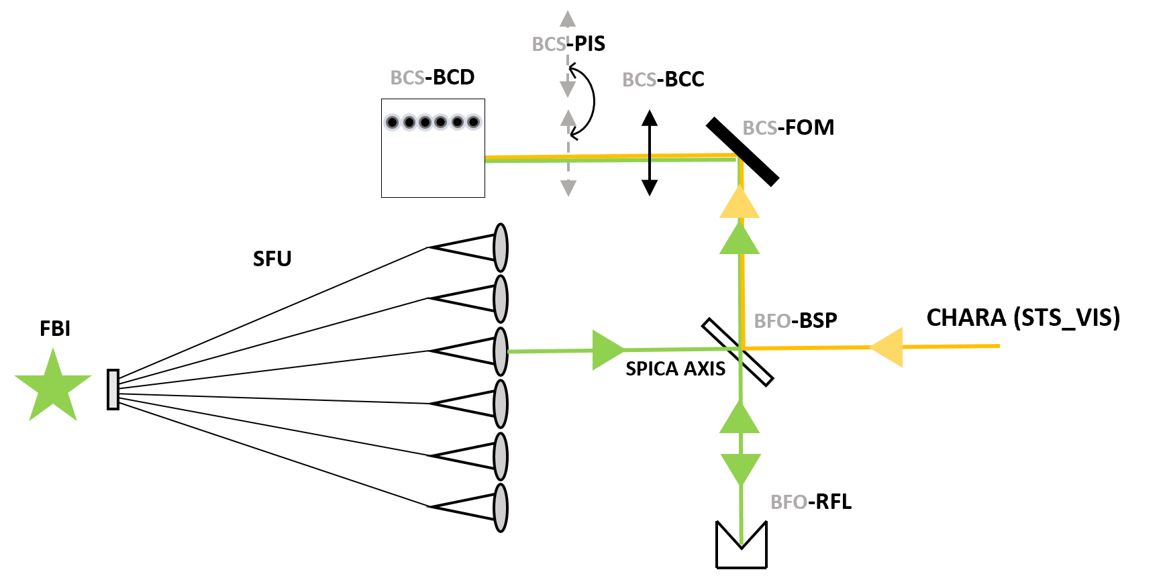
Figure 2: Schematic layout of the Beam Commuting System and the Fiber Back Illumination allowing the check of the co-alignment between SPICA_VIS and CHARA.
To determine the SPICA_VIS reference axis, the fibers in the V-groove of the Spatial Filter Unit (SFU) can be back-illuminated (FBI). To allow the feed of the BCS (Beam Control System) with the retro light from the spectrograph, 6 corner cubes called RFL (Reflectors) are installed.

2.2 The adjustment devices
The adjustment of the beams coming from the CHARA system is made at three different levels by three motorized and remotely controlled modules (see figures 3 and figure 4):
- Angular adjustment: The first module is on the CHARA visible table in the SPICA Feeding Optics (SFO) periscope. The second level is composed of 6 mirrors (one per beam) called IMG (figure 3). Two motors per mirror are used to adjust the tip/tilt of each beam (image adjustment). As these mirrors are not placed in a pupil plan, it is necessary to make a lateral correction of the beam after each angular adjustment. The resolution of the motors (8301NF from Newport) used to perform the tip/tilt adjustment is 30nm (for a stroke of 2 inches). Taking into account the lever arm of 30mm, this corresponds to a resolution of 0.2 as/lab (0.4 as/lab for the beam).

- Lateral adjustment: The second module is on the SPICA Injection Table in the Beam Adjustment System (BAS). 6 mirrors called PUP (figure 4) are used to adjust the lateral translations of the beams (pupil alignment). These mirrors are located at the image plan of lenses called FOC. The beams are then collimated after flat mirrors (TTT) by lenses (COL) identical to the FOC lens. Two motors are used to tip-tilt each PUP mirror and adjust the lateral positions of each beam (pupil adjustment). As these mirrors are placed in an image plan, it is not necessary in theory to make an angular correction of the beam after each lateral adjustment. This module is not yet mechanically designed but the use of picometer actuators 8301 from Newport (combined with a lever arm of 20mm and a FOC/COL focal length of 400m) will allow sub-millimetric lateral adjustment (a 1mm lateral adjustment corresponds to a flux loss of about 1% at the fiber injection level).

- OPD adjustment: The third module is on the SPICA Injection Table in the Spatial Filter Unit (SFU). Each injection module (INM) is mounted on a translation stage for the internal optical delay line SDL (SPICA Delay Line, see figure 4).
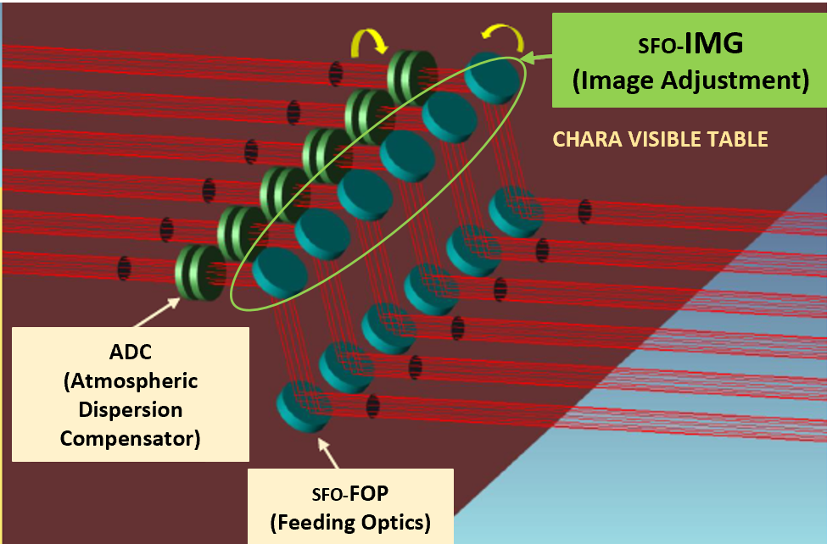 | Figure 3: The SPICA Feeding Optics (SFO) periscope on the CHARA visible table. The second level is composed by 6 mirrors called IMG. Two motors per mirror are used to adjust the tip/tilt of each beam (image adjustment).

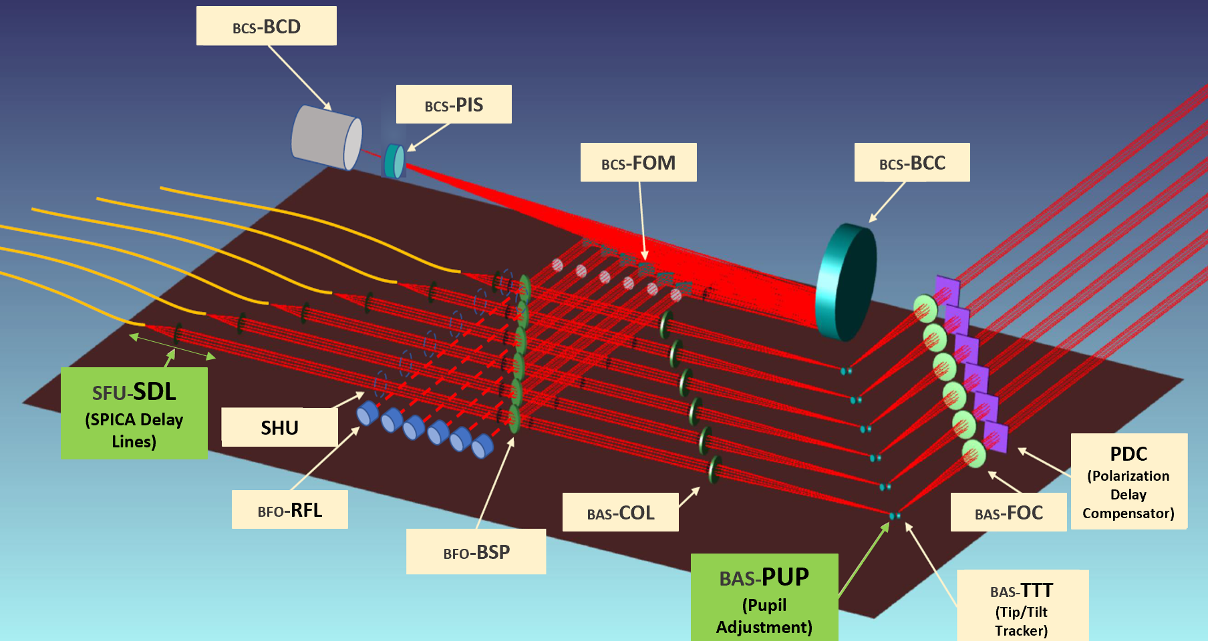
Figure 4: The SPICA Injection Table with the pupil adjustment device (PUP) in Beam Adjustment System (BAS) and the internal delay lines (SDL) at the entrance of the optical fiber.

Procedures

The procedures of the co-alignment and the co-phasing between CHARA and SPICA are remotely controlled and automatically executed. The sequences of actions are performed by “template(s)” that adjust automatically the IMG, the PUP and the SDL actuators according to the data recorded on the Beam Control Detector (BCD) or on the final SPICA detector (SDT).

2.1 Co-alignment procedure

Prerequisites:
- The STS source is co-aligned with the CHARA reference axis (and with the IR instruments MIRC or SPICA_FT).
- The laws “movement of IMG mirrors vs movement of images on the BCD” and “movement of PUP mirrors vs movement of pupils on the BCD” are calibrated

- First step: Determining of the SPICA reference axis (see figure 5)
  - Insert the Fiber Back Illumination system (FBI) in front of the V-groove input fiber: FBI=”IN”
  - Open the Shutters: SHU=”OPEN”
  - Switch ON the light of the FBI: FBI=”ON”. The light coming from the spectrograph reaches the Beam Control Detector (BCD) thanks to the retroflector (RFL)
  - Remove the lens allowing the pupil visualization (PIS): PIS=”IMG”
  - Record images on the BCD and compute the 6 photocenters corresponding to the 6 beams: I_{REFn} where n=1 , …, 6. (Angular references)
  - Insert the lens allowing the pupil visualization (PIS): PIS=”PUP”
  - Record pupils on the BCD and compute the 6 barycenters corresponding to the 6 beams: P_{REFn} where n=1 , …, 6. (Lateral references)
  - Switch off and remove the FBI: FBI=”OFF”, FBI=”OUT”

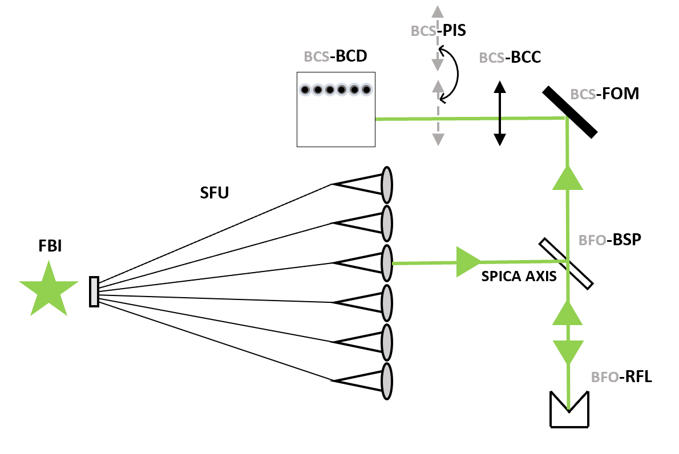
Figure 5: Instrumental setup during the determining of the SPICA reference axis.

- Second step: Co-alignment of the CHARA axis to the SPICA axis (see figure 6)
  - Switch ON the STS sources: STS-VIS=”ON”
  - Put the LDC-VIS at minimum thickness
  - Put the first mirrors of the SPICA feeding optics (SFO): FOP=”IN”
  - Put the ADC (Atmospheric Dispersion Compensator) in the “neutral” position (without refraction correction)
  - Put the TTT (Tip/Tilt Tracker) at middle stroke
  - Put the PDC (Phase Delay Compensator) in the right position to compensate the possible phase delay between polarization
  - Remove the lens allowing the pupil visualization (PIS): PIS=”IMG”
  - Record images on the BCD and compute the 6 photocenters corresponding to the 6 beams: I_{n} where n=1 , …, 6.
  - Compute the position differences ΔI_{n}=I_{n}-I_{REFn} between these images and the reference images. (Angular differences)
  - Adjust the IMG mirrors thanks to the 12 motors to compensate the angular differences (ΔI_{n})
  - Insert the lens allowing the pupil visualization (PIS): PIS=”PUP”
  - Record pupils on the BCD and compute the 6 photocenters corresponding to the 6 beams: P_{n} where n=1 , …, 6.
  - Compute the position differences ΔP_{n}=P_{n}-P_{REFn} between these images and the reference images. (Lateral differences)
  - Adjust the PUP mirrors thanks the 12 motors to compensate the lateral differences (ΔP_{n})
  - Verify the angular positions of the beam (remove the lens PIS=”IMG”, compute the positions of the images). If the image positions errors are greater than a given threshold (TBD), redo the procedure from step f.
  - Switch OFF the STS source.
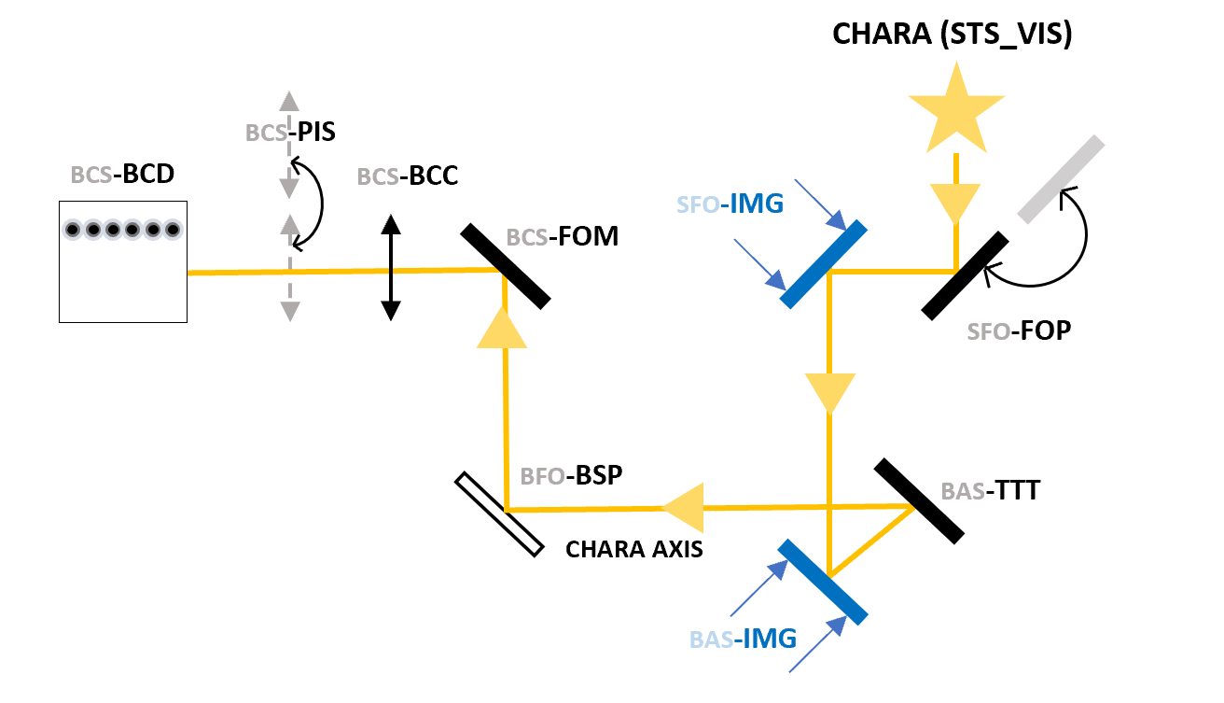
Figure 6: Instrumental setup during the adjustment of the CHARA axis to the SPICA reference axis.

2.2 Co-phasing procedure

Prerequisites: The IR instrument (MIRCx/SPICA-FT) is co-phased with the STS source. SPICA-VIS is co-aligned with the CHARA axis and the STS source.
The co-phasing procedure is the following
- Switch ON the STS sources: STS-VIS=”ON”
- Put the LDC-VIS at minimum thickness
- Put the first mirrors of the SPICA feeding optics (SFO): FOP=”IN”
- Put the ADC (Atmospheric Dispersion Compensator) in the “neutral” position (without refraction correction)
- Put the PDC (Phase Delay Compensator) in the right position to compensate the possible phase delay between polarization
- Put the TTT (Tip/tilt Tracker) at middle stroke
- Check alignment on BCD (pupil and images); lock TTT if needed
- Open the Shutters: SHU=”OPEN”
- Put the spectrograph at the highest resolution (DIS=”HDG”)
- Record dispersed fringes on the SDT (SPICA final detector)
- Compute the OPD between the 6 beams
- Adjust the SDL (SPICA internal Delay Lines) to compensate these OPD
- Put the spectrograph at the lowest resolution (DIS=”LDU”)
- Record dispersed fringes on the SDT (SPICA final detector)
- Compute the OPD between the 6 beams
- Adjust the SDL (SPICA internal Delay Lines) to compensate these OPD
- Switch OFF the STS source.

